Farhan Ali rizwan  
roll no 12  
BSDS -3A

Artificial Intelligence (lab)

### Film Finance Description of the Movie Budget Program

The **Movie Budget Program** tracks film production budgets, allowing users to view a list of movies with their budgets, add new entries, calculate the average budget, and identify which films exceed this average. It's a handy tool for analyzing film financing.

CODE:

movies = [

    ("the social network", 20000000),

    ("the fight club", 9000000),

    ("final destination", 4500000),

    ("fantastic 4", 379000000),

    ("superman", 365000000),

    ("Avengers: Endgame", 356000000),

    ("john wick", 200000000)

]

print("Do you want to add more movies? (yes/no)")

ans = input().strip().lower()

if ans == "yes":

    how_many = int(input("How many movies do you want to add? "))

    for i in range(how_many):

        print(f"Movie {i+1}:")

        title = input("Enter movie name: ")

        cost = int(input("Enter movie budget: "))

        movies.append((title, cost))

total = 0

for m in movies:

    total += m[1]

avg = total / len(movies)

print(f"\nAverage movie budget: ${avg}")

above = []

for m in movies:

    if m[1] > avg:

        gap = m[1] - avg

        above.append((m[0], gap))

        print(f"\n{m[0]} is above average by ${gap}")

print(f"\nTotal movies above average: {len(above)}")

Output:

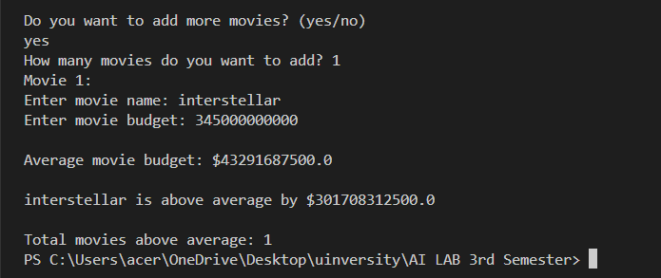

Explanation:

1. A list of movies is created, each stored as a pair containing its title and budget.
2. The program asks the user if they want to add more movies.
3. If the user chooses **yes**, they enter how many movies they want to add, and each new movie’s title and budget are collected and added to the list.
4. The total budget of all movies is calculated by summing up the budget values.
5. The **average budget** is computed by dividing the total budget by the number of movies.
6. The program prints the average budget.
7. A new list is created to track movies with a budget **above the average**.
8. For each movie above the average, the difference between its budget and the average is calculated and displayed.
9. Finally, the program shows the total number of movies that are above the average budget.